Under the Guidance of,

Professor Tathagata Ghosh

**Group L1, Section 2**

MR. SOURISH ATORTHY (21F258)

MR. MANJUL MAYANK TRIPATHI (21F233)

MR. M MANOHAR PRABHU (21F234)

MS. NISHU CHOUDHARY (21F237)

MR. SAURABH SINGH (21F252)

Differentiating heavy users and light users of e-payments

How to increase usage of e-payments?

**Contents**

**i. List of Tables** 2

**ii. List of Charts** 2

**1.** **Introduction** 3

1.1. History of E-Payments 3

1.2. The industry 3

1.3. About our client - Paytm 4

**2.** **The Managerial Problem** 5

2.1. Background of the Problem 5

2.2. Statement of the Problem 5

**3.** **Research Design** 6

3.1. Type of Research Design 6

3.2. Information Needs 6

3.3. Data Collection from Secondary Sources 7

3.4. Data Collection from Primary Sources 7

3.5. List of Variables and Scaling Technique 7

3.6. Questionnaire Development & Sampling Technique 8

**4. Data Analysis** 9

4.1. Methodology 9

4.2. Sample Profile & Initial Data Analysis 9

**5. Results** 10

5.1. Discriminant Model 10

5.2. Model Hypothesis & Wilks' Lambda Table 11

5.3. Group Statistics Table 11

5.4. Independent Variables Hypothesis: 12

5.5. Test of Equality of Group Means Table: 13

5.6. Eigen Values Table: 14

5.7. Structure Matrix: 14

5.8. Canonical Discriminant Function Coefficients: 15

5.9. Functions at Group Centroid: 16

5.10. Classification Statistics: 16

**6. Limitations to The Study** 16

**7. Conclusions & Recommendations** 17

**8. Exhibits** 17

8.1. Exhibit 1: The Survey Questionnaire 17

8.2. Exhibit 2: The Moderator’s Outline for the In-Depth Interview 20

8.3. Exhibit 3: Form Responses in MS-Excel 20

8.4. Exhibit 4: IBM SPSS Input - Variable View 25

**9. References & Important Links** 25

# **i. List of Tables**

|  |  |  |
| --- | --- | --- |
| Table Number | Table Content | Page Number |
| 1 | List of Variable & Scales Used | 8 |
| 2 | Wilks’ Lambda Table | 11 |
| 3 | Group Statistics Table | 11-12 |
| 4 | Test Of Equality of Group Means | 14 |
| 5 | Eigen Values Table | 14 |
| 6 | Structure Matrix | 15 |
| 7 | Canonical Discriminant Function Coefficients | 15 |
| 8 | Functions At Group Centroid | 16 |
| 9 | Classification Results Table | 16 |
| 10 | Form Responses In MS-Excel | 20-25 |
| 11 | IBM SPSS Input - Variable View | 25 |

# **ii. List of Charts**

|  |  |  |
| --- | --- | --- |
| Chart Number | Chart Content | Page Number |
| Pie Chart 1 | Number Of Heavy & Light Users Responded to Questionnaire | 9 |
| Pie Chart 2 | Age Demographics of The Responses | 10 |
| Pie Chart 3 | Number Of Transactions Per Month | 10 |
| Pie Chart 4 | Number Of Errors Per Month | 10 |

# **Introduction**

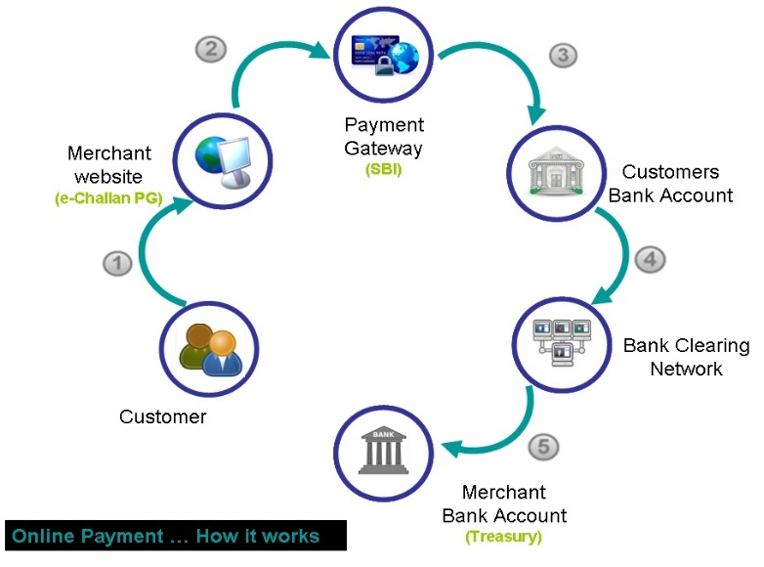

The days of fumbling for change in front of stores are long gone. Toffees are no longer given as change. Everything is now simple and convenient. The development of e-payments is the cause behind this. E-payment refers to any payment made through the internet for products or services. It comprises transactions made using electronic devices including computers, cell phones, and tablets. This includes credit cards, debit cards, online transfers, and online payment applications.

## 1.1. History of E-Payments

Western Union introduced the electronic fund transfer (EFT) in 1871, and e-payments began in the 1870s. Payments underwent a slow but steady transition from the 1870s until the late 1960s. The Federal Reserve of America began using the telegraph to transmit money in the 1910s. Diner's Club International became the first independent credit card corporation in the 1950s, closely followed by American Express. The first plastic card for electronic payments was offered to the globe by American Express in 1959. Customers have had access to Internet banking since the 1990s. During that time, user-friendliness was a key concern with internet payments. During the early days, special equipment and software were necessary to transfer a payment for products. Now, payment acceptance can be integrated into websites, mobile platforms, etc.

## 1.2. The industry

With the introduction of new online payment, the online payment business is becoming increasingly competitive, and user ease and happiness are being prioritised to obtain a competitive edge. This industry has been transformed by the introduction of modern technology and innovation. User-friendliness, transaction clarity, advertisements, user interface, processing speed, refund time, and other factors all contribute to a mobile payment app's success. Smartphones have boosted the usage of online payments. Because everything was at their fingertips, users became acclimated to the technology. Online shopping sites were another element that contributed to the rise in online payments. People have become reliant on online payments for online shopping sites due to its ease and dependability.

However, there are several disadvantages to using the internet to make a payment. Payments are frequently not completed, and a bad network connection might result in a money transfer but no updates. Furthermore, some of the user interfaces are not appropriate for users of all ages. Due to a variety of issues, e-payment has failed to reach a large number of clients. With the implementation of demonetization and the Digital India campaign, there is an increasing awareness and demand for e-payments, as seen by the vast number of stores and businesses that now provide this option. It is expected to rise in the future as a cashless economy becomes more prevalent.

## 1.3. About our client - Paytm

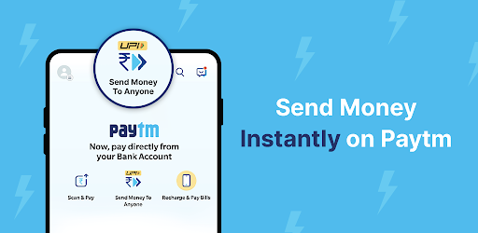Paytm (or pay through mobile) is a Noida-based fintech firm that is owned by One97 Communications. Paytm is one of the top mobile payment and e-commerce companies in India. It also offers Paytm Wallet and Paytm UPI in addition to Paytm Mall (which was introduced in the year 2017). Because of the wide range of items and services offered by this app, we may term it a megastore. On the Paytm app, customers may do anything that has to do with online payments. As a result, it is the most widely used payment app in India, ranking third on our list of the top UPI applications in India. Through the Paytm app or the Paytm website, it is possible to conduct cashless transactions.

Paytm First, a subscription-based loyalty programme, was launched in March 2019, and in May, the company teamed with Citibank to offer the Paytm First credit card. Paytm secured $1 billion in a fundraising round headed by T Rowe Price, along with previous investors Ant Financial and SoftBank Vision Fund, on November 25, 2019.

Paytm wallet allows one to store and transmit money across wallets, as well as pay straight from their bank account using UPI. One may top up their mobile phones, metro cards, data cards, and DTH cable, as well as pay their utility bills and post-paid bills. Alternatively, one may use it to buy movies and plane tickets, purchase online, or use it at a variety of places including taxis, grocery stores, restaurants, malls, and so on.

# **The Managerial Problem**

## 2.1. Background of the Problem

Paytm is in the market of E-Payments since 2010. Since its inception, it has had a good customer base, with over 150 million active users as of 2021, which is one of the largest amongst the other competitors. But as of November 2021, Paytm has 260.09 million transactions in volume with Rs 28,986.93 Cr in transaction value. This figure is quite low in the industry even. With so many users actually registering in various e-payment apps, the transaction volume was still considerably low. This was troubling the company as the company was doing decent in converting non-E-payment users to an E-Payment user but was not doing good in making them use E-Payment increasingly in various aspects.

## 2.2. Statement of the Problem

The problem faced by the company in recent times is the number of users of e-payments are although quite high, but the number of transactions per user is incredibly low. To understand the problem, the marketing team of the company has asked to perform a research on understanding the factors which differentiate the heavy and light users of e-payments. If the factors are understood, then the light users can therefore be transformed into heavy users as the company would understand what is making the light users not use e-payments on a higher scale.

# **Research Design**

## 3.1. Type of Research Design

To understand the problem, we used **Descriptive Research Design**. Descriptive research design is a type of study that aims to collect data in order to describe a phenomenon, situation, or population in a systematic way. It mostly assists in answering the what, when, where, and how questions about the research challenge, rather than the why. A descriptive research has the following characteristics:

* Descriptive research is gathering quantitative and systematic data that may be used to analyse the study problem statistically.
* One of the most distinguishing features of descriptive research is that the variables are not controlled or changed, as they are in experimental research. They are merely recognised, seen, and measured instead.
* The data gathered in descriptive research serves as a foundation for subsequent study since it aids in gaining a thorough grasp of the research topic so that it may be effectively answered.
* Cross-sectional studies are commonly used in the descriptive approach of research. A cross-sectional study is an observational research in which data on a number of variables is collected at the person level at a certain point in time.

## 3.2. Information Needs

The research was broken into multiple steps. The first step was to understand what information we need and where can we get it from. First, we had to understand about the industry and the background of the problem. So, to understand that we looked through different secondary data sources, like websites, newspaper web articles, etc. But these were not enough. We had to understand the real mindset of an e-payment user and for that we could not rely upon secondary sources. We tried to understand what factors make a user use more or less of e-payments.

## 3.3. Data Collection from Secondary Sources

For gathering information about the industry and our client we looked through various websites, blogs and online articles published in various newspapers (please refer to **References** at the end of the document to know about the sources). We understood the background for the problem our client company has through the secondary sources and hence had a slight idea what could be the problem’s actual cause. But we still were not close to figuring out although the user base was so high, why the users were not using the e-payments in the adequate amount. For this we had to talk to real users of e-payments, so that we can understand their mindset for using or not using e-payments.

## 3.4. Data Collection from Primary Sources

To understand the factors which may differentiate amongst a heavy and a light user of e-payments, we collected data from primary sources. Initially we conducted **in-depth interviews** of seven different users of e-payments in their vernacular for our qualitative research. This helped us get an honest and unclouded vision of the users as they were more open in their vernaculars than in English. We used the **laddering technique** with a set of questions (please refer to exhibit number 1) which brought out the reason the user considers himself or herself as a heavy or light user of e-payments.

We identified a set of variables through the In-Depth interviews and then decided on to perform a quantitative research using a questionnaire designed in Google Form.

## 3.5. List of Variables and Scaling Technique

From the in-depth interviews we saw a bunch of variables like monthly transactions, monthly errors, security, availability were repeating themselves in all the replies.

We therefore listed these variables down and thought of a scaling technique for each of them. They are as follows:

|  |  |  |
| --- | --- | --- |
| Table 1 | | |
| Name of Variable | **Type of Variable** | **Scale of Variable** |
| Type of Users | Dependent Variable; Dichotomous in nature | Nominal  (1: Light User, 2: Heavy User) |
| Age | Independent Variable | Ratio Scale |
| Monthly Transactions | Independent Variable | Ratio Scale |
| Monthly Errors | Independent Variable | Ratio Scale |
| Security | Independent Variable | 5-Point Likert Scale* |
| Promotions & Discounts | Independent Variable | 5-Point Likert Scale |
| App Interface | Independent Variable | 5-Point Likert Scale |
| Reduction of Carrying Cash | Independent Variable | 5-Point Likert Scale |
| Ready Availability | Independent Variable | 5-Point Likert Scale |
| Reduction of Human Interaction | Independent Variable | 5-Point Likert Scale |
| Tech Savviness | Independent Variable | 5-Point Likert Scale |
| *\*Here, 1 is Strongly Disagree, 2 is Somewhat Disagree, 3 is Neither Agree nor Disagree, 4 is Somewhat Agree & 5 is Strongly Agree* | | |

## 3.6. Questionnaire Development & Sampling Technique

After we were ready with our variables and the scales they will be in, we started preparing the questionnaire in Google Forms which we planned to circulate electronically only. Our target population were users with a smartphone and use e-payments. They included people from varied backgrounds like students, professionals, homemakers, retired people. We used **judgement sampling** to send our questionnaire to. We used a similar kind of technique to find a small sample for pretesting.

We had questions for each of our variables. The dependent variable question had just two option because it was **dichotomous**. We targeted user who had a bank account and hence a UPI, so the minimum age for people who we targeted had to be 18 years. So, we put appropriate checks in our questionnaire to check that no user is typing an age below 18 years by mistake. We were also considering only users of E-Payments for our study. So, we kept a check to see at least the user has performed one monthly transaction. Otherwise, the user does not qualify for any aspect of our study. Finally, we also checked if the number of errors happening monthly is at least zero, as number of errors cannot be negative. We gathered the information about the other variables using **5-point Likert scale** questions (Please refer to Exhibit 2 for detailed questions asked in the Google Form).

# **4. Data Analysis**

## 4.1. Methodology

After successful data collection, it was time to understand how to use this data to distinguish between heavy and light users of e-payments. We decided on using **Discriminant Analysis**, with **α = 0.05**, for our research. Discriminant analysis is a statistical technique for grouping non-overlapping observations based on scores on one or more quantitative predictor variables. We were performing a two-group discriminant analysis as our dependent variable was supposed to be divided into two groups. The biggest difference between discriminant analysis and standard regression analysis is the use of a categorical variable as a dependent variable. Other than that, the two-group discriminant analysis is just like standard multiple regression analysis.

We chose to use **Microsoft Excel** for our initial data analysis and **IBM SPSS** for performing the discriminant analysis.

## 4.2. Sample Profile & Initial Data Analysis

After we distributed the questionnaire amongst various users, we got a fairly good response from everybody. We collected a total of 125 responses (apart from the pretesting responses) in a matter of 1 day. Using the data if we do an initial profiling we understand:

**Chart 1**

* 54% of the users who responded were heavy users and 46% of the users were light. So, we had a very balanced response sheet with almost equal responses from both type of users.
* Chart, pie chart

  Description automatically generatedAge demographics were spread out between 18-21, 22-25, 26-29 and 30+ years old. We had the highest representations from the 22-25 students or first-time employees’ section of about 54%, followed by age demographics of 26-29 years.

**Chart 2**

* Chart, pie chart

  Description automatically generatedIf we were to look into the number of monthly transactions, it ranged from as low as 1 to 7 transaction a month to 40+ transactions a month. Most users said that they perform 15-21 transactions a month (26%). A high percentage of users were performing 29-35 transactions a month (22%).

**Chart 3**

* Chart, pie chart

  Description automatically generatedFinally, we had the number of errors faced monthly while performing transactions. We had respondents saying that they face 0 to 3 errors per month at an average (68%).

**Chart 4**

# **5. Results**

## 5.1. Discriminant Model

Type of E-Payment User (D0) = b0 + b1.(Age) + b2.(Monthly Transactions) + b3.(Monthly Errors) + b4.(Security) + b5.(Application Interface) + b6.(Reduction of Carrying Cash)+ b7.(Promotions & Discounts) + b8.(Ready Availability) + b9.(Reduction of Direct Human Interaction) + b10.(Tech-Savviness)

## 5.2. Model Hypothesis & Wilks' Lambda Table

H0: The discriminant model is not statistically significant

Ha: The discriminant model is statistically significant

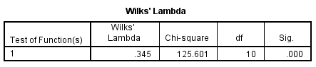

**Table 2**

So, we **reject the null hypothesis** as significance is less than our α which is 0.05

## 5.3. Group Statistics Table

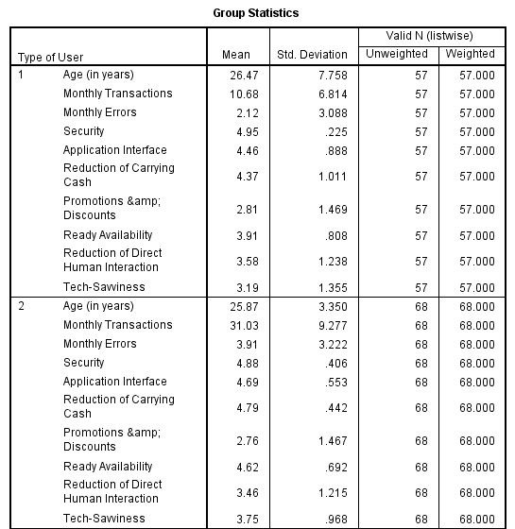

**Table 3**

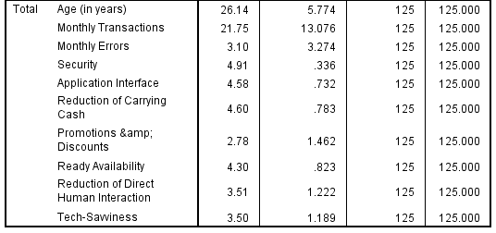

**Table 3 (Cont.)**

The group table mainly contains the mean, standard deviation, and the size of the sample of variable for each type of user and the combined total. It does not show conclusive result about the impact of the variables but gives a general idea. The difference in the means between the 2 groups, if high, means the variable is impacting in the discrimination.

After a quick visual inspection, we can see that there is a good difference in the means of monthly transactions and errors, and the ready availability variables. So, they might be good variables to determine the difference among users. Later, in another table we will validate this assumption.

## 5.4. Independent Variables Hypothesis:

H10: Mean of the Age doesn’t vary much between the two groups

H1a: Mean of the Age vary between the two groups

H20: Mean of the Monthly Transactions doesn’t vary much between the two groups

H2a: Mean of the Monthly Transactions vary between the two groups

H30: Mean of the Monthly Errors doesn’t vary much between the two groups

H3a: Mean of the Monthly Errors vary between the two groups

H40: Mean of the Importance to Security doesn’t vary much between the two groups

H4a: Mean of the Importance to Security vary much between the two groups

H50: Mean of the Importance to Application Interface doesn’t vary much between the two groups

H5a: Mean of the Importance to Application Interface vary between the two groups

H60: Mean of the Importance to Reduction of Carrying Cash doesn’t vary much between the two groups

H6a: Mean of the Importance to Reduction of Carrying Cash vary between the two groups

H70: Mean of the Importance to Promotions & Discounts doesn’t vary much between the two groups

H7a: Mean of the Importance to Promotions & Discounts vary between the two groups

H80: Mean of the Importance to Ready Availability doesn’t vary much between the two groups

H8a: Mean of the Importance to Ready Availability vary between the two groups

H90: Mean of the Importance to Reduction of Direct Human Interaction doesn’t vary much between the two groups

H9a: Mean of the Importance to Reduction of Direct Human Interaction vary between the two groups

H100: Mean of the Importance to Tech-Savviness doesn’t vary much between the two groups

H10a: Mean of the Importance to Tech-Savviness vary between the two groups

## 5.5. Test of Equality of Group Means Table:

From this table (Table 4) we can say Monthly Transactions, Monthly Errors, Reduction of Carrying Cash, Ready Availability & Tech-Savviness are the discriminating variables amongst the two groups of users. Wilks' Lambda range between 0 to 1 & lower the value, the higher is the differentiating power of the variable. So, Monthly Transactions differentiate the groups the most followed by ready availability, month errors and so forth.

**Table 4**

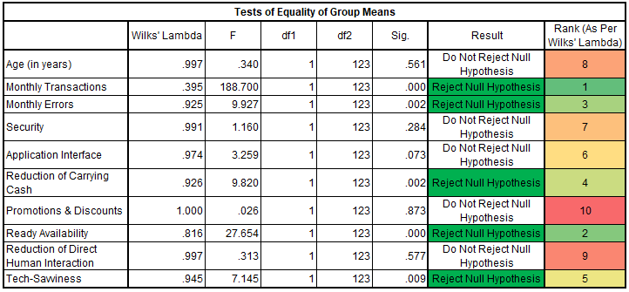

## 5.6. Eigen Values Table:

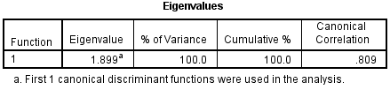

**Table 5**

The correlation between the dependent and independent variables is 0.809. Square of that is 0.6545. So, **65.45% of the variance in usage of e-payments is explained by the discriminant model**.

Eigen value is the ratio of between group variance and within group variance. The higher the value of Eigen value the better is the model. But we cannot say anything with this as we would need another model's eigen value to actually compare.

## 5.7. Structure Matrix:

Structure matrix (Table 6) ranks the variables for their importance in differentiating the users similarly like Wilks' Lambda. But here, higher the structure loadings are, the more important the variable is. So, the Wilks' Lambda table and this should ideally converge, and we can see it is actually converging.

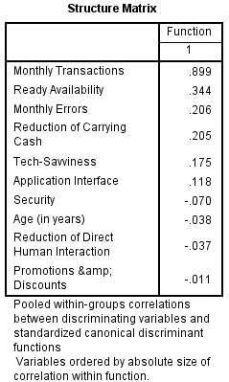

**Table 6**

## 5.8. Canonical Discriminant Function Coefficients:

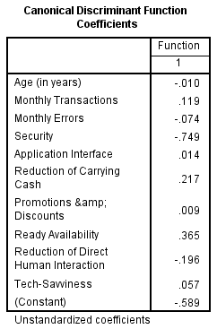

**Table 7**

From this table, if we use the coefficients the model becomes,

Type of E-Payment User (D0) = – 0.589 – 0.010(Age) + 0.119(Monthly Transactions) – 0.074(Monthly Errors) – 0.749(Security) + 0.014(Application Interface) + 0.217(Reduction of Carrying Cash) + 0.009(Promotions & Discounts) + 0.365(Ready Availability) – 0.196(Reduction of Direct Human Interaction) + 0.057(Tech-Savviness)

## 5.9. Functions at Group Centroid:

If we multiply each value with the coefficients and add the constant, we will get the z-score of each data point. Taking the average of all z-scores of a particular group will give the group centroid. With the group centroid we can calculate the cutting score. The cutting score is -0.2413. Now if a new data point comes, we will calculate the z-score of this user and if it is greater than -0.2413 then it belongs to Group 2 and vice versa.

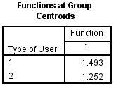

**Table 8**

## 5.10. Classification Statistics:

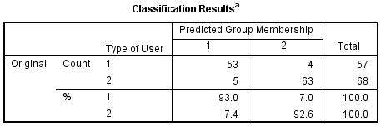

**Table 9**

SPSS calculates all the discriminant z-scores and re-evaluates the grouping. Here, it found that as per our model 58 should be light users and 67 heavy users and our model is wrongly classifying 9 users. So, our **hit ratio is ((53/57)+(63/68))/2 = 92.8%.** Evidently, our **miss ratio will be 100-92.8 = 7.2%.**

# **6. Limitations to The Study**

The Limitations to our study were:

* We used Judgement Sampling for our quantitative data, which has a chance of sampling errors of its own.
* Higher percentage of our In-Depth Interviews identified themselves as heavy users of e-payments. So, we had lower perspective of a light user.

# **7. Conclusions & Recommendations**

With our study, we could see what factors differentiate a heavy and light user of E-Payments. With that we can also understand what factors are more important to the different types of users. So, from the research we understand and hence recommend are:

* Users using e-payments once every 3 days are light users and once every day are heavy users broadly.
* Light users face 20% times errors monthly compared to 12% of heavy users, so they don't choose e-payments more.
* Light users don't find e-payments to be readily available. So, digital payments need to be incorporated in more places.
* Light users don't find themselves to be tech-savvy enough to use e-payments. So, technicalities in e-payment apps or sites needs to be reduced to increase usage.

# **8. Exhibits**

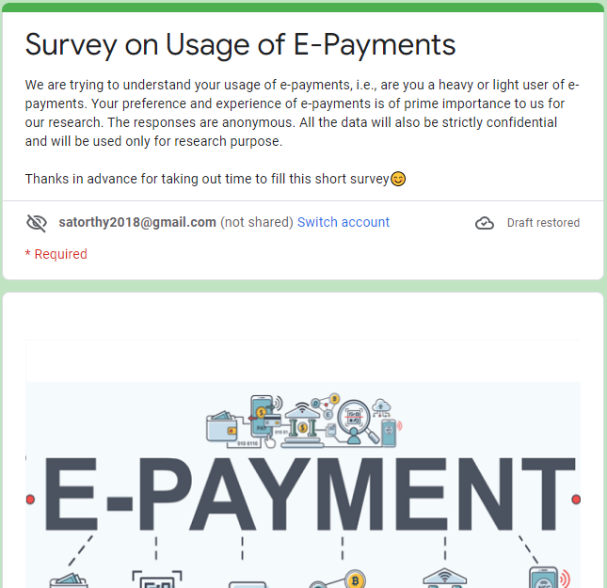

## 8.1. Exhibit 1: The Survey Questionnaire

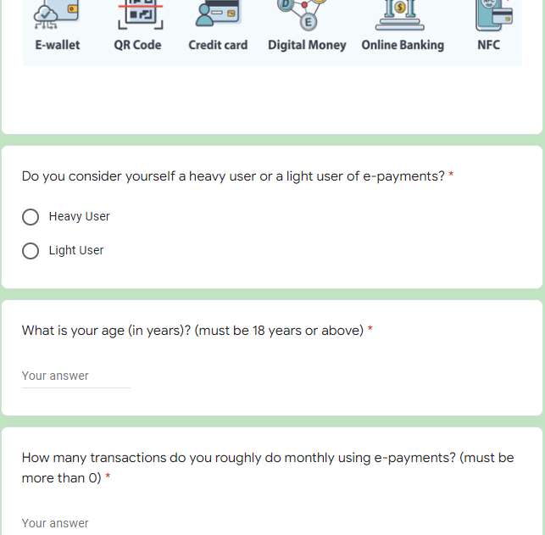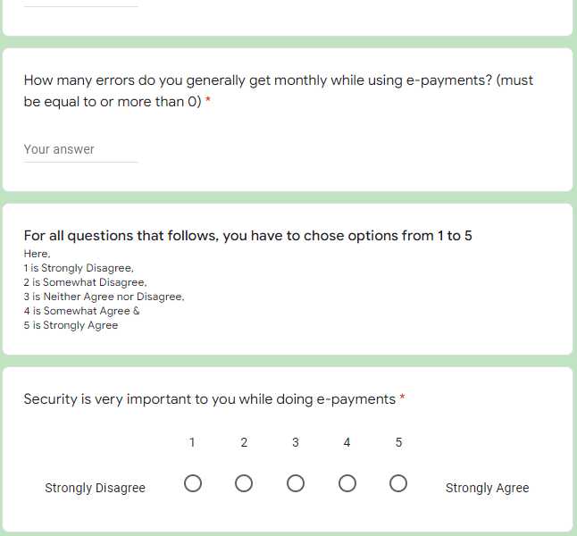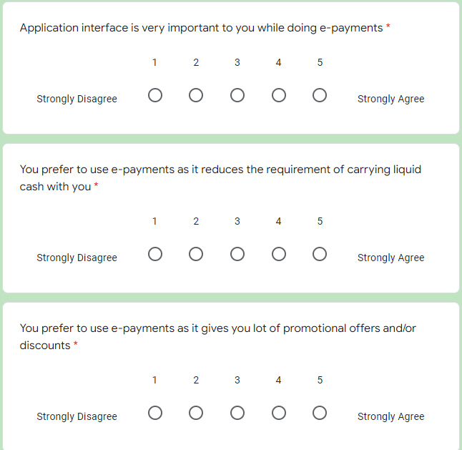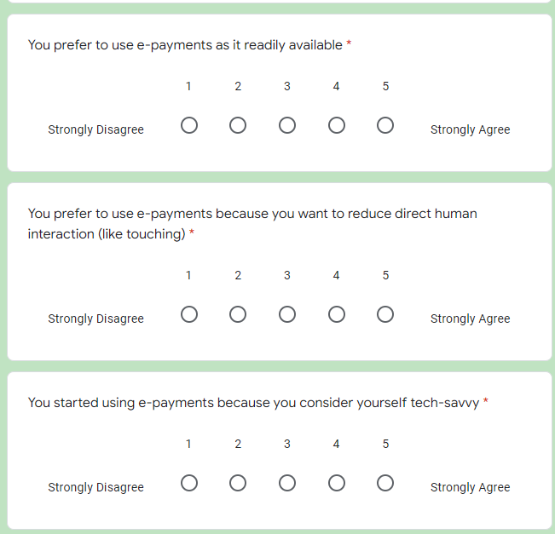

## 8.2. Exhibit 2: The Moderator’s Outline for the In-Depth Interview

* What are your views on online or mobile banking?
* What are your views on e-payments?
* Do you use E-Payments? If yes, when did you start?
* Do you consider yourself heavy or light user?
* How much cash do you prefer to carry with you?
* How many transactions do you roughly do weekly?
* Why do/don’t you prefer e-payments?
* Where do you generally use e-payments?
* Did you start using them because word of mouth or did you find any actually use case for it?
* How do you view the interface of e-payment apps?
* How important is security for doing e-payments?
* What are the problems of carrying cash?
* How often do you get error while e-payments?
* E-Payments give good rewards and cashbacks. Please comment.

## 8.3. Exhibit 3: Form Responses in MS-Excel

|  |  |  |  |  |  |  |  |  |  |  |  |
| --- | --- | --- | --- | --- | --- | --- | --- | --- | --- | --- | --- |
| **Table 10** | | | | | | | | | | | |
| **User Type** | **Type of User (1=Light, 2=Heavy)** | **Age (in years)** | **Monthly Transactions** | **Monthly Errors** | **Security** | **Application Interface** | **Reduction of Carrying Cash** | **Promotions & Discounts** | **Ready Availability** | **Reduction of Direct Human Interaction** | **Tech-Savviness** |
| Light User | 1 | 25 | 1 | 0 | 5 | 3 | 1 | 1 | 1 | 1 | 2 |
| Light User | 1 | 27 | 2 | 0 | 5 | 4 | 1 | 1 | 4 | 2 | 2 |
| Light User | 1 | 25 | 8 | 0 | 5 | 4 | 2 | 3 | 3 | 1 | 3 |
| Light User | 1 | 45 | 27 | 3 | 3 | 3 | 3 | 2 | 4 | 4 | 5 |
| Light User | 1 | 23 | 10 | 2 | 5 | 5 | 3 | 3 | 4 | 2 | 4 |
| Light User | 1 | 70 | 2 | 2 | 4 | 5 | 3 | 5 | 4 | 4 | 5 |
| Light User | 1 | 23 | 5 | 1 | 5 | 5 | 3 | 1 | 4 | 3 | 3 |
| Heavy User | 2 | 31 | 15 | 0 | 5 | 5 | 3 | 2 | 4 | 2 | 3 |
| Heavy User | 2 | 26 | 5 | 0 | 5 | 2 | 3 | 5 | 2 | 4 | 1 |
| Heavy User | 2 | 24 | 4 | 0 | 4 | 3 | 3 | 5 | 4 | 3 | 4 |
| Heavy User | 2 | 25 | 6 | 0 | 5 | 5 | 3 | 3 | 4 | 1 | 5 |
| Light User | 1 | 24 | 30 | 10 | 5 | 5 | 4 | 2 | 4 | 4 | 2 |
| Heavy User | 2 | 25 | 40 | 5 | 5 | 5 | 4 | 4 | 5 | 3 | 4 |
| Light User | 1 | 25 | 30 | 5 | 5 | 5 | 4 | 3 | 5 | 5 | 5 |
| Light User | 1 | 26 | 30 | 5 | 5 | 5 | 4 | 4 | 4 | 3 | 3 |
| Light User | 1 | 22 | 15 | 4 | 5 | 5 | 4 | 5 | 3 | 3 | 3 |
| Heavy User | 2 | 26 | 40 | 3 | 5 | 4 | 4 | 3 | 5 | 4 | 4 |
| Heavy User | 2 | 23 | 10 | 2 | 5 | 4 | 4 | 3 | 3 | 2 | 4 |
| Heavy User | 2 | 29 | 10 | 2 | 5 | 5 | 4 | 3 | 4 | 5 | 3 |
| Heavy User | 2 | 24 | 15 | 2 | 5 | 2 | 4 | 3 | 4 | 3 | 3 |
| Light User | 1 | 27 | 35 | 2 | 5 | 5 | 4 | 2 | 5 | 3 | 4 |
| Light User | 1 | 27 | 35 | 2 | 3 | 3 | 4 | 2 | 2 | 2 | 3 |
| Light User | 1 | 25 | 30 | 2 | 4 | 5 | 4 | 4 | 5 | 5 | 3 |
| Light User | 1 | 31 | 50 | 2 | 5 | 4 | 4 | 3 | 5 | 3 | 4 |
| Heavy User | 2 | 26 | 10 | 1 | 4 | 4 | 4 | 4 | 3 | 3 | 3 |
| Light User | 1 | 18 | 4 | 1 | 5 | 3 | 4 | 3 | 3 | 2 | 3 |
| Light User | 1 | 25 | 4 | 1 | 5 | 4 | 4 | 5 | 4 | 5 | 4 |
| Light User | 1 | 25 | 8 | 1 | 5 | 5 | 4 | 1 | 4 | 3 | 1 |
| Heavy User | 2 | 26 | 28 | 1 | 4 | 3 | 4 | 2 | 3 | 3 | 5 |
| Heavy User | 2 | 22 | 10 | 0 | 5 | 5 | 4 | 5 | 4 | 4 | 5 |
| Heavy User | 2 | 27 | 5 | 0 | 5 | 4 | 4 | 2 | 4 | 2 | 3 |
| Light User | 1 | 23 | 15 | 0 | 5 | 5 | 4 | 1 | 4 | 4 | 4 |
| Light User | 1 | 25 | 30 | 0 | 5 | 5 | 4 | 2 | 5 | 2 | 3 |
| Light User | 1 | 30 | 35 | 0 | 5 | 5 | 4 | 1 | 5 | 2 | 2 |
| Light User | 1 | 30 | 40 | 20 | 5 | 5 | 5 | 5 | 4 | 4 | 4 |
| Light User | 1 | 24 | 30 | 15 | 5 | 5 | 5 | 5 | 5 | 5 | 5 |
| Heavy User | 2 | 23 | 20 | 10 | 5 | 4 | 5 | 1 | 4 | 3 | 2 |
| Heavy User | 2 | 25 | 30 | 10 | 5 | 4 | 5 | 2 | 4 | 3 | 3 |
| Heavy User | 2 | 26 | 25 | 10 | 5 | 5 | 5 | 1 | 5 | 5 | 4 |
| Heavy User | 2 | 26 | 30 | 10 | 5 | 5 | 5 | 3 | 4 | 5 | 1 |
| Heavy User | 2 | 22 | 40 | 10 | 5 | 5 | 5 | 5 | 5 | 5 | 4 |
| Heavy User | 2 | 22 | 40 | 10 | 5 | 5 | 5 | 5 | 5 | 3 | 5 |
| Heavy User | 2 | 22 | 40 | 10 | 5 | 5 | 5 | 4 | 5 | 5 | 4 |
| Heavy User | 2 | 24 | 50 | 8 | 5 | 4 | 5 | 2 | 4 | 4 | 3 |
| Heavy User | 2 | 26 | 20 | 8 | 5 | 5 | 5 | 4 | 3 | 4 | 3 |
| Heavy User | 2 | 27 | 50 | 7 | 5 | 5 | 5 | 5 | 5 | 4 | 5 |
| Light User | 1 | 21 | 40 | 6 | 5 | 4 | 5 | 5 | 4 | 1 | 3 |
| Heavy User | 2 | 26 | 30 | 6 | 5 | 5 | 5 | 3 | 5 | 5 | 3 |
| Heavy User | 2 | 25 | 50 | 6 | 5 | 5 | 5 | 5 | 5 | 5 | 5 |
| Heavy User | 2 | 24 | 30 | 6 | 5 | 4 | 5 | 4 | 3 | 5 | 3 |
| Heavy User | 2 | 24 | 15 | 5 | 5 | 4 | 5 | 3 | 4 | 4 | 4 |
| Heavy User | 2 | 23 | 30 | 5 | 5 | 4 | 5 | 1 | 5 | 2 | 3 |
| Heavy User | 2 | 23 | 30 | 5 | 5 | 5 | 5 | 1 | 5 | 4 | 3 |
| Heavy User | 2 | 26 | 25 | 5 | 5 | 5 | 5 | 5 | 5 | 3 | 4 |
| Heavy User | 2 | 25 | 40 | 5 | 5 | 5 | 5 | 3 | 5 | 5 | 4 |
| Heavy User | 2 | 27 | 20 | 5 | 5 | 5 | 5 | 5 | 5 | 5 | 5 |
| Heavy User | 2 | 27 | 40 | 5 | 5 | 5 | 5 | 1 | 5 | 1 | 5 |
| Heavy User | 2 | 26 | 20 | 5 | 5 | 5 | 5 | 2 | 5 | 5 | 3 |
| Heavy User | 2 | 22 | 20 | 5 | 5 | 5 | 5 | 3 | 5 | 5 | 5 |
| Heavy User | 2 | 23 | 20 | 5 | 5 | 4 | 5 | 1 | 5 | 2 | 3 |
| Heavy User | 2 | 26 | 20 | 5 | 5 | 5 | 5 | 2 | 4 | 3 | 3 |
| Light User | 1 | 27 | 30 | 5 | 5 | 5 | 5 | 1 | 5 | 3 | 4 |
| Light User | 1 | 25 | 30 | 5 | 5 | 5 | 5 | 3 | 5 | 5 | 4 |
| Heavy User | 2 | 27 | 20 | 5 | 5 | 5 | 5 | 5 | 5 | 2 | 3 |
| Heavy User | 2 | 30 | 50 | 5 | 5 | 5 | 5 | 4 | 5 | 4 | 5 |
| Heavy User | 2 | 23 | 15 | 4 | 5 | 4 | 5 | 5 | 4 | 5 | 3 |
| Light User | 1 | 26 | 15 | 4 | 5 | 4 | 5 | 2 | 4 | 5 | 4 |
| Light User | 1 | 24 | 30 | 4 | 5 | 4 | 5 | 1 | 5 | 1 | 5 |
| Light User | 1 | 24 | 30 | 4 | 5 | 5 | 5 | 2 | 5 | 3 | 3 |
| Heavy User | 2 | 23 | 25 | 4 | 5 | 4 | 5 | 5 | 4 | 4 | 3 |
| Heavy User | 2 | 23 | 5 | 3 | 5 | 5 | 5 | 2 | 4 | 3 | 2 |
| Heavy User | 2 | 25 | 12 | 3 | 5 | 4 | 5 | 3 | 4 | 4 | 5 |
| Heavy User | 2 | 25 | 10 | 3 | 5 | 5 | 5 | 2 | 4 | 5 | 2 |
| Heavy User | 2 | 26 | 30 | 3 | 5 | 5 | 5 | 2 | 5 | 3 | 3 |
| Light User | 1 | 24 | 30 | 3 | 5 | 5 | 5 | 2 | 3 | 5 | 5 |
| Light User | 1 | 26 | 45 | 3 | 4 | 4 | 5 | 3 | 3 | 4 | 3 |
| Light User | 1 | 26 | 30 | 3 | 5 | 5 | 5 | 1 | 4 | 2 | 2 |
| Light User | 1 | 26 | 20 | 3 | 5 | 5 | 5 | 3 | 5 | 2 | 5 |
| Light User | 1 | 26 | 12 | 2 | 5 | 4 | 5 | 1 | 4 | 3 | 1 |
| Light User | 1 | 24 | 4 | 2 | 5 | 5 | 5 | 2 | 3 | 3 | 3 |
| Light User | 1 | 25 | 15 | 2 | 5 | 5 | 5 | 3 | 4 | 4 | 5 |
| Light User | 1 | 22 | 10 | 2 | 5 | 5 | 5 | 3 | 4 | 5 | 5 |
| Heavy User | 2 | 24 | 15 | 2 | 5 | 5 | 5 | 3 | 5 | 3 | 3 |
| Heavy User | 2 | 38 | 10 | 2 | 5 | 5 | 5 | 2 | 5 | 4 | 3 |
| Heavy User | 2 | 26 | 15 | 2 | 5 | 5 | 5 | 1 | 4 | 3 | 2 |
| Heavy User | 2 | 26 | 10 | 2 | 5 | 4 | 5 | 2 | 4 | 4 | 3 |
| Heavy User | 2 | 24 | 20 | 2 | 4 | 4 | 5 | 4 | 4 | 5 | 5 |
| Heavy User | 2 | 24 | 20 | 2 | 5 | 4 | 5 | 1 | 5 | 3 | 2 |
| Heavy User | 2 | 27 | 40 | 2 | 5 | 5 | 5 | 1 | 5 | 2 | 4 |
| Heavy User | 2 | 23 | 35 | 2 | 5 | 5 | 5 | 2 | 5 | 2 | 3 |
| Heavy User | 2 | 26 | 30 | 2 | 5 | 4 | 5 | 1 | 5 | 1 | 2 |
| Heavy User | 2 | 25 | 40 | 2 | 5 | 5 | 5 | 1 | 5 | 3 | 3 |
| Heavy User | 2 | 25 | 30 | 2 | 5 | 5 | 5 | 2 | 5 | 5 | 5 |
| Heavy User | 2 | 26 | 20 | 2 | 5 | 5 | 5 | 1 | 5 | 3 | 3 |
| Heavy User | 2 | 27 | 30 | 2 | 5 | 5 | 5 | 1 | 5 | 4 | 3 |
| Heavy User | 2 | 25 | 20 | 2 | 5 | 4 | 5 | 2 | 5 | 3 | 5 |
| Heavy User | 2 | 30 | 40 | 2 | 5 | 5 | 5 | 1 | 5 | 3 | 3 |
| Light User | 1 | 24 | 30 | 2 | 5 | 5 | 5 | 1 | 5 | 3 | 5 |
| Light User | 1 | 23 | 25 | 2 | 5 | 5 | 5 | 5 | 5 | 3 | 4 |
| Light User | 1 | 25 | 50 | 2 | 5 | 5 | 5 | 4 | 5 | 5 | 4 |
| Light User | 1 | 30 | 20 | 2 | 5 | 5 | 5 | 3 | 5 | 5 | 5 |
| Light User | 1 | 23 | 10 | 1 | 5 | 5 | 5 | 1 | 4 | 5 | 1 |
| Light User | 1 | 23 | 10 | 1 | 5 | 5 | 5 | 1 | 4 | 5 | 1 |
| Light User | 1 | 27 | 10 | 1 | 5 | 5 | 5 | 5 | 4 | 5 | 5 |
| Light User | 1 | 22 | 3 | 1 | 5 | 5 | 5 | 5 | 4 | 5 | 3 |
| Light User | 1 | 26 | 15 | 1 | 5 | 5 | 5 | 1 | 5 | 5 | 5 |
| Heavy User | 2 | 36 | 7 | 1 | 5 | 1 | 5 | 4 | 1 | 2 | 1 |
| Heavy User | 2 | 23 | 5 | 1 | 5 | 5 | 5 | 4 | 4 | 2 | 1 |
| Light User | 1 | 25 | 8 | 1 | 5 | 5 | 5 | 2 | 4 | 5 | 3 |
| Light User | 1 | 33 | 15 | 1 | 5 | 5 | 5 | 5 | 4 | 3 | 4 |
| Light User | 1 | 35 | 20 | 1 | 5 | 4 | 5 | 2 | 4 | 3 | 4 |
| Light User | 1 | 25 | 20 | 1 | 5 | 5 | 5 | 2 | 5 | 4 | 3 |
| Light User | 1 | 23 | 10 | 0 | 5 | 4 | 5 | 2 | 4 | 3 | 4 |
| Light User | 1 | 23 | 5 | 0 | 5 | 5 | 5 | 1 | 4 | 5 | 1 |
| Light User | 1 | 26 | 10 | 0 | 5 | 5 | 5 | 1 | 4 | 5 | 5 |
| Light User | 1 | 24 | 15 | 0 | 5 | 5 | 5 | 5 | 5 | 5 | 5 |
| Heavy User | 2 | 26 | 1 | 0 | 5 | 5 | 5 | 5 | 5 | 5 | 5 |
| Heavy User | 2 | 55 | 5 | 0 | 5 | 5 | 5 | 3 | 5 | 3 | 5 |
| Heavy User | 2 | 25 | 15 | 0 | 5 | 5 | 5 | 3 | 5 | 3 | 3 |
| Heavy User | 2 | 25 | 3 | 0 | 5 | 5 | 5 | 2 | 4 | 3 | 2 |
| Heavy User | 2 | 26 | 25 | 0 | 5 | 5 | 5 | 4 | 4 | 4 | 3 |
| Heavy User | 2 | 27 | 20 | 0 | 5 | 5 | 5 | 5 | 5 | 5 | 5 |
| Heavy User | 2 | 25 | 20 | 0 | 5 | 5 | 5 | 2 | 5 | 2 | 4 |
| Heavy User | 2 | 24 | 30 | 0 | 5 | 5 | 5 | 5 | 4 | 3 | 3 |
| Heavy User | 2 | 26 | 20 | 0 | 5 | 5 | 5 | 1 | 5 | 3 | 5 |

## 8.4. Exhibit 4: IBM SPSS Input - Variable View

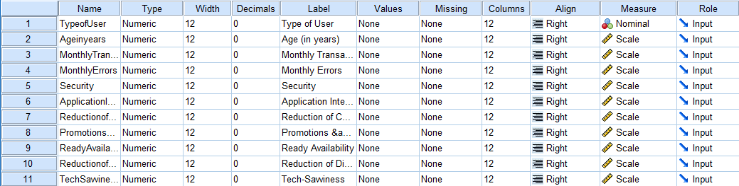

**Table 11**

# **9. References & Important Links**

* Link to survey questionnaire, <https://forms.gle/GmfZGVWetdkPv13p6>
* Electronic Payments: A Brief History, CSG Forte Team, July 27, 2021, <https://www.forte.net/electronic-payments-a-brief-history/#:~:text=Electronic%20payments%20have%20their%20roots,the%20point%2Dof%2Dsale>.
* 5 Best UPI Apps in India in 2022, Trade Brains, Jan 10, 2022, <https://tradebrains.in/best-upi-apps-in-india/>
* Best Digital Payment Apps In India, Reuters, Sep 14, 2021, <https://www.compareremit.com/money-transfer-guide/best-digital-payment-apps-in-india/#:~:text=With%20over%20150%20million%20active,%2416%20billion%20as%20of%202020>.
* Paytm, Wikipedia, 3 April 2022, <https://en.wikipedia.org/wiki/Paytm>